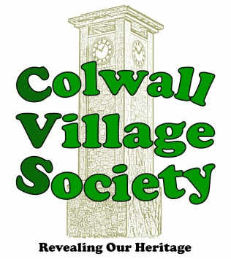

**CVS Membership**

Membership of the Colwall Village Society gives you free access to our speaker meetings as well regular newsletters with information about the history and natural history of Colwall.

Our membership year begins on 1st April each year and costs **£5.00 per person**.

By providing your contact information on this form you are permitting the Colwall Village Society to hold this information. We take your privacy seriously and will never share your information with third parties. Our full [Data Protection Statement](http://www.cvs.colwall.info/GDPR.pdf) can be read on our website.

**------------------------------------------------------------------------------------------------------------------------------------------------------**

**NAME(S) …………………………………………………………………………………………………..…………..**

**ADDRESS ………………………………………………………………………………………..……………………..**

**………………………………………………………………………………..……………………………..**

**POST CODE ............................................................. TEL. NO. …….………………..……….........................**

**EMAIL ……………………………………………………………………………………..……………………......**

I wish to receive the newsletter by email **………………… Yes / No**

Receiving the newsletter by email saves the society money and keeps the subscription low.

**Payment Methods**

* Cash
* Cheque (payable to Colwall Village Society)
* Bank Transfer **( Colwall Village Society**

Sort Code: **30-95-41** Account No**. 00554770**. Ref: **Your name)**

**SIGNED ……………………….…………..………………….….…….…. DATE ……………..…………….**

To enrol as a member, please return or email this form along with your subscription to

Alan Seddon, 1 Acorn Close, Colwall, Malvern, WR13 6LJ

email [cvsmember@colwall.info](mailto:cvsmember@colwall.info) Tel no. 01684 541547

.

**1.** By filling in this form you are agreeing to Colwall Village Society holding your data by both paper and electronic means.

The Society undertakes to use the data solely for the purpose of transmitting to you: newsletters , notices, details of forthcoming events

**2.** Your data will be removed from our database 6 months after your membership lapses.

**3.** Under *The Data Protection Act 1998* and *The General Data Protection Regulations 2018* you, as a member, have various rights regarding your data including: right of access, right of correction, right of review, right of erasure

**4.** The society’s Processing Officer/Membership Secretary can be contacted at **cvsmember@colwall.info**